TASK 4: MINI PROJECT – ROBOTICS /AUTOMATION PROPOSAL
HUMANOID ROBOT DESIGN CONCEPTS

SUBMITTED BY: BATOOL FATIMA (ROBOTICS INTERN)

Abstract

Humanoid robotics has moved from experimental laboratory prototypes toward commercially deployed platforms capable of operating alongside humans in real industrial and service environments. This mini project examines the core design concepts behind modern humanoid robots, including mechanical structure and degrees of freedom, actuation technologies, sensing and perception systems, balance and locomotion control, and the AI architectures that allow these robots to interpret their surroundings and act autonomously. Drawing on current industry platforms such as Boston Dynamics' Atlas, Agility Robotics' Digit, and Unitree's H1, the report outlines a conceptual design framework for a general-purpose humanoid robot, identifies the major engineering challenges that remain unresolved, and discusses the trajectory of the humanoid robotics market. The project concludes that while significant technical barriers persist in locomotion, dexterity, and power efficiency, rapid progress in actuator design and AI-driven control is steadily closing the gap between research prototypes and commercially viable humanoid platforms.

Table of Contents
1. Introduction ....................................................................................................3
2. Objective .........................................................................................................3
3. Design Concept Overview ..............................................................................3
4. Mechanical Structure and Degrees of Freedom ..............................................4
5. Actuation Technologies ..................................................................................4
6. Sensing and Perception Systems .....................................................................4
7. Balance and Locomotion Control ...................................................................5
8. AI and Control Architecture ..........................................................................5
9. Real-World Reference Platforms ....................................................................5
10. Engineering Challenges ................................................................................6
11. Market Outlook ............................................................................................6
12. Conclusion ....................................................................................................6
References ..........................................................................................................7

Introduction

A humanoid robot is a machine designed with a body structure that broadly resembles the human form — a head, torso, two arms, and typically two legs — enabling it to operate within environments and infrastructure originally built for humans. Unlike wheeled or fixed industrial robots, humanoids can climb stairs, open doors, navigate cluttered spaces, and manipulate tools designed for human hands. This versatility has made humanoid robotics one of the fastest-growing areas of robotics research and commercialization, with platforms such as Boston Dynamics' Atlas and Agility Robotics' Digit transitioning from laboratory demonstrations into active pilot deployments in warehouses and factories. This mini project explores the fundamental design concepts that make such robots possible, covering mechanical structure, actuation, sensing, control, and the broader engineering challenges still facing the field.

Objective

• Define the conceptual mechanical structure of a general-purpose humanoid robot, including its degrees of freedom (DOF).
• Examine the actuation technologies used to drive humanoid joints with sufficient force, precision, and compliance.
• Identify the sensing and perception systems required for balance, navigation, and object manipulation.
• Outline how balance and locomotion are controlled in bipedal humanoid systems.
• Discuss the AI and control architecture that enables autonomous decision-making.
• Reference real-world humanoid platforms to ground the design concept in current industry practice.
• Identify unresolved engineering challenges and outline the projected growth of the humanoid robotics market.

Design Concept Overview

The proposed conceptual design follows the architecture used by most modern industrial humanoid platforms: a bipedal lower body for locomotion, a torso housing the main computing and power systems, two articulated arms for manipulation, and a sensor-equipped head for perception. The design prioritizes modularity, allowing individual limbs or sensor packages to be upgraded independently, and emphasizes a centralized AI control system capable of coordinating perception, balance, and manipulation tasks in real time.

Mechanical Structure and Degrees of Freedom

The mechanical structure of the proposed humanoid robot is organized into five major segments, each contributing a portion of the robot's total degrees of freedom:
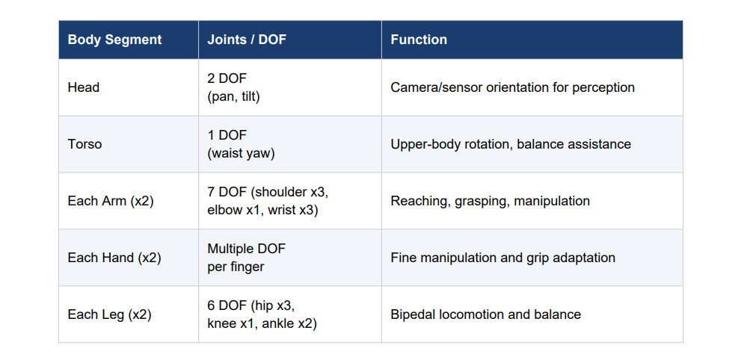
With two arms contributing roughly 14 DOF, two legs contributing roughly 12 DOF, and additional DOF in the torso, head, and hands, a full-scale general-purpose humanoid commonly exceeds 28–30 total degrees of freedom in the body alone, with current commercial platforms integrating tens of additional actuators in the hands for fine dexterity. This high DOF count is essential for replicating human-like range of motion but introduces substantial complexity in real-time control and coordination.

Actuation Technologies

Each joint in a humanoid robot requires an actuator capable of delivering sufficient torque while remaining compact and energy-efficient. Three actuation approaches dominate current humanoid design:
• Electric actuators with strain-wave (harmonic drive) gearboxes — widely used for their compactness, backlash-free operation, and high torque density, making them the most common choice in modern electric humanoids.
• Series Elastic Actuators (SEAs) — incorporate a spring element between the motor and joint, enabling accurate force sensing without dedicated force sensors, absorbing shock during walking, and improving energy efficiency during locomotion cycles.
• Hydraulic and electro-hydrostatic actuators — offer very high power density and are sometimes used in heavy-duty research platforms, though they introduce greater complexity in fluid management and maintenance.
Each actuator assembly typically combines a gearbox, motor control electronics, a frameless brushless DC motor, precision mechanical components, and integrated sensors, all packed into a thermally constrained, compact housing. The proposed design adopts electric actuators with strain-wave gearing for the legs and torso, where precise position control is critical, and considers series elastic actuation for the arms to allow safer, more compliant interaction with humans and objects.

Sensing and Perception Systems

A humanoid robot must continuously sense both its internal state (proprioception) and its external environment (exteroception) to maintain balance and interact safely. The proposed sensor suite includes:
• Inertial Measurement Units (IMUs) — placed in the torso and limbs to track orientation, angular velocity, and acceleration for balance control.
• Joint torque and position sensors — embedded at each actuator to provide closed-loop feedback for precise motion and force control.
• Stereo and depth cameras — mounted in the head to provide 3D perception of the environment for navigation and object recognition.
• LiDAR or time-of-flight sensors — for longer-range obstacle detection and mapping in dynamic environments.
• Tactile sensors in the hands — to detect contact, slip, and grip force during manipulation tasks. • Force/torque sensors in the feet — to detect ground contact and weight distribution, critical for maintaining balance while walking on uneven terrain.

Balance and Locomotion

Control Bipedal locomotion remains one of the most demanding control problems in robotics, since a humanoid must continuously balance its center of mass over a small, shifting base of support. The proposed control approach is based on the well-established Zero Moment Point (ZMP) method, supplemented by whole-body control techniques that coordinate the legs, torso, and arms simultaneously to maintain stability. The control loop operates as follows: IMU and foot force sensors continuously estimate the robot's center of mass and balance state; a locomotion planner generates a walking gait or stepping trajectory based on the desired movement; and a whole-body controller distributes joint torques across the legs and torso to execute the trajectory while compensating for disturbances such as uneven terrain or external pushes. This closed-loop process must run at high frequency (typically hundreds of times per second) to react quickly enough to prevent falls.

AI and Control Architecture

Modern humanoid robots increasingly rely on a layered control architecture that separates low-level stability control from high-level cognitive decision-making:
• Low-level control layer — runs balance and joint control loops at high frequency, ensuring the robot remains stable regardless of what task it is performing.
• Mid-level planning layer — converts high-level goals (e.g., “pick up the box on the shelf”) into specific motion trajectories for the arms and legs.
• High-level AI layer — uses vision-language-action models and large language models to interpret natural language instructions, recognize objects and scenes, and plan multi-step tasks autonomously. This layered approach allows the same underlying hardware to be reprogrammed for new tasks through software updates rather than mechanical redesign, which is a key reason recent AI advances have accelerated the practical deployment of humanoid robots in commercial settings.

Real-World Reference Platforms
The proposed design concept draws on several current commercial and research humanoid platforms:
• Boston Dynamics Atlas — a fully electric, human-scale bipedal platform shown at CES 2026, designed for manufacturing and logistics tasks such as palletizing, integrating stereo and depth cameras, IMUs, and joint torque/position sensors. Pilot deployments are underway with Hyundai and other industrial partners.
• Agility Robotics Digit — a bipedal humanoid deployed in active fulfillment centers, including a GXO-operated facility, where it autonomously moves totes between mobile robots and conveyors without operator intervention.
• Unitree H1 — a commercially available full-size bipedal robot priced around $90,000, notable for its walking speed and modular upgrade options, making humanoid hardware more accessible for research and development.

Engineering Challenges

Despite rapid progress, several fundamental engineering challenges remain unresolved across the humanoid robotics field:
• Bipedal locomotion robustness — reliably walking across varied, unstructured terrain (stairs, slopes, debris) remains substantially harder than walking on flat factory floors.
• Dexterous manipulation — achieving human-level fine motor control in robotic hands, especially for unfamiliar or deformable objects, is still an open research problem.
• Power efficiency — humanoid robots require significant onboard power for sustained operation, and battery technology remains a limiting factor for continuous multi-hour deployment.
• Actuator cost and customization — there is currently no standardized “engine supplier” for humanoid actuators; every major project develops custom actuation, which increases cost and slows scaling.
• Safety around humans — force-limited actuators, emergency stop systems, and proximity sensors are necessary but must be continually improved as robots operate in closer proximity to people.

Market Outlook

The humanoid robotics market is experiencing rapid growth driven by simultaneous advances in AI capability, hardware cost reduction, and growing industrial demand for flexible automation. The global humanoid robot market was valued at approximately $1.8 billion in 2023, and is projected by MarketsandMarkets to reach $13.8 billion by 2028, reflecting a compound annual growth rate exceeding 50%. Some longer-term forecasts are considerably more ambitious, with Morgan Stanley's research division projecting a potential market value of $5 trillion by 2050, predicated on the possibility that billions of humanoid units could eventually be integrated into daily commercial and domestic life. While such long-range projections carry significant uncertainty, the near-term trajectory toward industrial pilot deployments, as already seen with Atlas and Digit, suggests substantial commercial momentum in the current decade.

Conclusion

Humanoid robot design integrates mechanical engineering, advanced actuation, multi-modal sensing, real-time control theory, and modern AI into a single coordinated platform. The conceptual design outlined in this report — built around a 28+ DOF bipedal structure, strain-wave and series-elastic actuation, a comprehensive sensor suite, ZMP-based balance control, and a layered AI control architecture — reflects the design principles already being validated in commercial platforms such as Atlas, Digit, and the Unitree H1. While locomotion robustness, dexterity, power efficiency, and actuator standardization remain significant open challenges, the pace of progress across the industry suggests that humanoid robots will continue moving from pilot programs toward broader commercial and domestic deployment over the coming decade.

References

1. Electronics360 (GlobalSpec). 2026 Humanoid Robot Launches. https://electronics360.globalspec.com/article/23332/2026-humanoid-robot-launches
2. PatSnap. Humanoid Robot Actuators: 530,554+ Patents Analysed. https://www.patsnap.com/resources/blog/articles/humanoid-robot-actuators-530554-patents-analysed/
3. KraneShares. Humanoid Robotics In 2026: The Race From Pilot To Platform. https://kraneshares.com/humanoid-robotics-in-2026-the-race-from-pilot-to-platform/
4. Robotics and Automation News. The Engineering Challenges Behind Humanoid Robots: Locomotion, Dexterity and Power Efficiency. https://roboticsandautomationnews.com/2026/03/12/challenges-in-bipedal-l ocomotion-dexterous-manipulation-and-power-efficiency/99584/
5. Standard Bots. Humanoid Robots in 2026: Types, Prices, and What's Next. https://standardbots.com/blog/humanoid-robot
6. Robozaps. Future of Humanoid Robots [2026].
https://blog.robozaps.com/b/future-of-humanoid-robots

